**DreamPod**

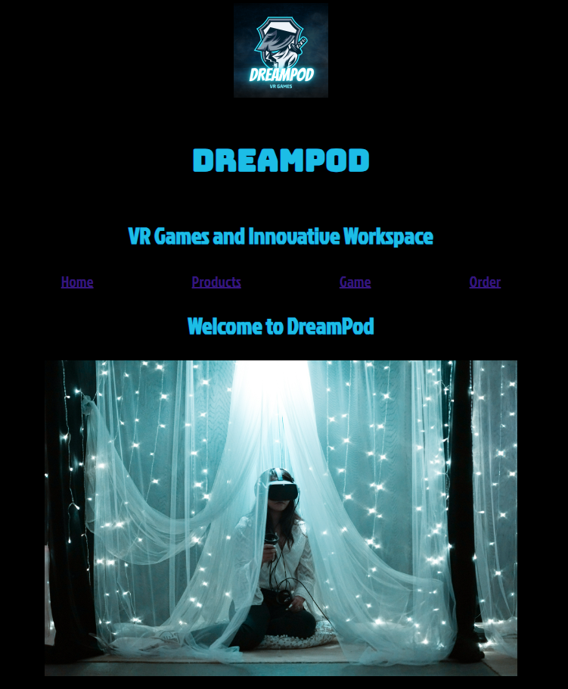

David Power

**Submitted to:** Hamilton Niculescu

Friday 8th of December 2023

Table of Contents

1. Executive Summary 3

2. Project Work 4

3. Design Process 5

4. Testing & Responsiveness 9

5. Conclusion 9

6. References 10

# Executive Summary

**Why VR/AR?** Although the rate of expansion has not slowed down to yet, the growing number of VR application cases suggests a quick paradigm transition. In addition, there are significant adoption initiatives in place to motivate the industry and consumer industries to use this technology. Although a breakthrough has not yet been achieved, the future appears bright because major international firms like IKEA, Audi, DHL, and Airbus have adopted VR technology.[1]

**Problem Statement:** Our primary objective is to address the existing limitations in the VR/AR market, such as fragmented solutions, high entry barriers, and the lack of customized, scalable applications. Current offerings often fail to meet the diverse needs of businesses and individuals, hindering the widespread adoption of VR/AR technologies.

**Solution:** VR/AR Innovations Hub presents a comprehensive suite of VR/AR solutions tailored to meet the unique requirements of diverse industries. Our prototype website showcases a user-friendly platform where clients can explore and customize VR/AR applications, making these technologies more accessible and adaptable to specific business needs.

**Key Features:**

1. **Customization:** Tailor VR/AR solutions to suit industry-specific requirements.
2. **Ease of Use:** Intuitive interface for users to navigate and customize applications effortlessly.
3. **Collaboration:** Foster collaboration through shared immersive experiences in virtual spaces.
4. **Scalability:** Scale applications to accommodate the evolving needs of businesses.

**Market Size:** The global VR market is expected to rise from less than 12 billion US dollars in 2022 to more than 22 billion US dollars by 2025, indicating how quickly the industry is expanding. The predicted expansion is anticipated to benefit both the consumer and enterprise industries, as well as the growing VR gaming market.[2]

# Project Work

1. **Phase 1: Planning and Design**
   * *Work Package 1: Project Kick-off*
     + **Milestone:** Project kick-off meeting
     + **Deliverable:** Project plan, roles and responsibilities defined
   * *Work Package 2: Requirements Gathering*
     + **Milestone:** Completed requirements document
     + **Deliverable:** Detailed list of application features and specifications
   * *Work Package 3: Design Phase*
     + **Milestone:** Approval of wireframes and design mock-ups
     + **Deliverable:** User interface and mid-level prototype designs
2. **Phase 2: Development**
   * *Work Package 4: Backend Development*
     + **Milestone:** Completion of backend architecture
     + **Deliverable:** Backend system ready for integration
   * *Work Package 5: Frontend Development*
     + **Milestone:** Initial version of the user interface implemented
     + **Deliverable:** Functional frontend for basic user interactions
3. **Phase 3: Testing and Optimization**
   * *Work Package 6: Testing*
     + **Milestone:** Completion of initial testing
     + **Deliverable:** Bug reports and testing documentation
4. **Phase 4: Deployment and Launch**
   * *Work Package 7: Integration*
     + **Milestone:** Successful integration of all components and user needs
     + **Deliverable:** Fully integrated website ready for deployment
   * *Work Package 8: Launch*
     + **Milestone:** Platform launch
     + **Deliverable:** Website live and accessible to users

# Design Process

* **Colour Palette:**
  + Chose a futuristic and immersive colour palette: Deep blue (#001F3F), Electric blue (#0074D9), and Light teal (#7FDBFF).
  + Reasons: Evokes a sense of technology, professionalism, and depth, aligning with the immersive nature of VR/AR.
* **Fonts:**
  + Selected modern and clean fonts for readability: Montserrat (header) and Open Sans (body).
  + Reasons: Offers a balance between sophistication and clarity, ensuring a pleasant reading experience.
* A blue and black screen

  Description automatically generated with medium confidence**Homepage:**

**Design Pattern Reference:** Hero Image with Call-to-Action (CTA)

* Reason: Captures attention with a visually striking VR/AR experience image, guiding users to explore further.
* **Product Page:**

**Design Pattern Reference:** Card Design

* Reason: Utilizes card-based layout for individual VR/AR applications, presenting information in a structured and visually appealing format.
* **Game Page:**

**Gaming Element Reference:**

* User requirement.
* Incorporated subtle interaction for a dynamic and engaging user experience without overwhelming the interface.
* A screen shot of a computer

  Description automatically generated**Order Page:**

**Design Pattern Reference:** Multi-Step Form

* Reason: Breaks down the ordering process into manageable steps, enhancing user experience and reducing potential form fatigue.

**Final Design:**

* Achieved a cohesive and visually appealing design that reflects the innovative and immersive nature of VR/AR technologies.
* Prioritized user experience, readability, and engagement throughout the website.

# Testing & Responsiveness

**Optimization and SEO:** Efficient optimization and SEO practices are crucial for improving the website's performance and visibility in search engine results.

* **Image Optimization:** Compressed and appropriately sized images to reduce page load times, enhancing the overall performance.
* **Minification of CSS and JavaScript:** Reduced file sizes by minifying CSS and JavaScript files, accelerating load times.
* **SEO-Friendly URLs and Meta Tags:** Ensured URLs are descriptive and included relevant meta tags (title, description, keywords) for improved search engine indexing.

**JavaScript Implementation:** JavaScript is utilized to enhance the website's interactivity and dynamic elements. Common JavaScript constructs such as loops and conditional statements are applied for various functionalities.

* **Loops:** Implemented loops for iterating through arrays of data, such as product listings on the home and product pages, ensuring dynamic content display.
* **Conditional Statements:** Employed if statements for conditional logic, facilitating responsive design adjustments based on user interactions or device characteristics.

# Conclusion

**Challenges:** While the project was generally successful, there were challenges encountered along the way, incorporating dynamic elements with JavaScript required meticulous testing to guarantee seamless functionality.

**Website Appearance:** The website's visual aesthetic aligns well with the futuristic and immersive theme we envisioned. The carefully chosen colour palette, clean typography, and engaging visuals successfully convey the essence of VR/AR technologies. The responsive design ensures a consistent and enjoyable experience for users across different devices, fostering accessibility and inclusivity.

**Potential Changes:** Given more time, there are aspects of the website that could be further refined and expanded upon. Continuous user feedback and iterative testing could be used to enhance the user interface, ensuring an even more intuitive and delightful experience. Additionally, the integration of more advanced VR/AR features could be explored as technology continues to evolve.

# References

* Nestor Gilbert, Oct 20, 2023, ‘74 Virtual Reality Statistics You Must Know in 2023: Adoption, Usage & Market Share’, [online] Available at: <https://financesonline.com/virtual-reality-statistics> [Accessed Nov 30, 2023].
* *Thomas Alsop, Aug 31, 2023, ‘virtual reality (VR) – statistics & facts’, [online] Available at:* [*https://www.statista.com/topics/2532/virtual-reality-vr/#topicOverview*](https://www.statista.com/topics/2532/virtual-reality-vr/#topicOverview) *[Accessed Nov 30, 2023].*

1. *Nestor Gilbert, Oct 20, 2023, ‘74 Virtual Reality Statistics You Must Know in 2023: Adoption, Usage & Market Share’, [online] Available at:* [*https://financesonline.com/virtual-reality-statistics/*](https://financesonline.com/virtual-reality-statistics/) *[Accessed Nov 30, 2023].*
2. *Thomas Alsop, Aug 31, 2023, ‘virtual reality (VR) – statistics & facts’, [online] Available at:* [*https://www.statista.com/topics/2532/virtual-reality-vr/#topicOverview*](https://www.statista.com/topics/2532/virtual-reality-vr/#topicOverview) *[Accessed Nov 30, 2023].*